Yigit Serdar

100367792

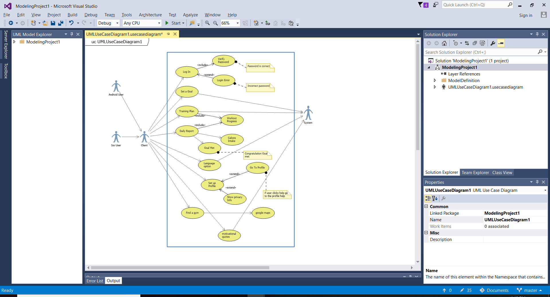Abhijiit Sen Info 1113

|  |  |
| --- | --- |
| Use Case Title | set goal |
| Primary Actor | User |
| Level | Kite (summary) |
| Stake Holder | User |
| Pre-condition | Know his capability |
| Minimal guarantee | Motivation |
| Success guarantee | One should be determined to complete his goal |
| trigger | One should set his goal according to his capability |
| Main Success scenario | * Complete the task * Be determined * Be consistent * Manage the time |
| Extension | May get demotivated and leave the task |